CaDeT INSTRUCTORs CADRE

lesson plan
Identification And Lesson Information
Instructor: | Date:
PO / EO number: M101.01 | EO title: Canadian Symbols
Teaching points:  - National Flag of Canada;  - Canadian National Anthem  - Canadian Coat of Arms  - The Maple Leaf | Duration: 30 minutes
 | Performance statement: Participate in a Discussion on Canadian Symbols.
Method(s): a. Interactive Lecture: allows instructor to make a semi-formal presentation of material where cdts can participate by asking or responding to questions and commenting on material. Effective as it matches well the taxonomic level of material and is age-appropriate by virtue of its participatory nature.  b. Activity: allows maximum participation in learning process. Interactive way to illustrate and substantiate lesson material in a concrete manner. | Standard: IAW specified refs, cdt shall participate in a discussion on Canadian symbols, to include:  a. National Flag of Canada;  b. Canadian National Anthem;  c. Canadian Coat of Arms; and  d. the maple leaf.
Conditions: a. Given:
(1) supervision; and
(2) assistance as required.
b. Denied: N/A.
c. Environmental: Suitable classroom facilities to accommodate the entire grp.

References: Government of Canada. (1995). Symbols of Canada; and Canadian Heritage Website. (2006). Retrieved 16 March 2006, from http:// www.canadianheritage.gc.ca. | Test details: No formal evaluation of this EO or PO.
 | Trainees level: First year cdts (ages 12 – 14)
Material needed for lesson: N/A | Training aids: a. Presentation aids: flipcharts and OHP  b. Picture of Canadian Coat of Arms found in Chapter 1, Annex A of training docs
Pre-lesson assignment: N/A
Classroom setting: Set up in semi-circular fashion so that everyone can see ec other to facilitate discussion with flipcharts and areas for trg aids as required. | Learning aids: a. Flipchart paper and marker;  b. Cut-outs of Canadian Coat of Arms found in trg docs Chapter 1, Annex A; and  c. Yellow Bristol board.
Orientation board:
60 mins Name

M101.01 – Canadian Symbols
1. Canadian Flag
2. National Anthem
3. Coat of Arms
4. The Maple Leaf

Refs Test Details

Activity Quiz at end of class

Refs: Govt of Canada

Review / Approach | Time | Action
In this PO – Participate in Citizenship Activities, we are going to be doing a number of activities that are aimed at enhancing or building your knowledge of various Canadian symbols that are found at the corps / sqn and in our community. | 30 secs

Introduction | Time | Action
Teaching points
- National Flag of Canada;  - Canadian National Anthem  - Canadian Coat of Arms  - The maple leaf | 2 mins | Orientation Board
Importance (Why)
By the end of this lesson you should be able to recognize and/or appreciate the significance of our National Flag of Canada, our national anthem, the Canadian Coat of Arms and the maple leaf.

Recognizing and knowing the significance of Canadian symbols is an important aspect of being a Canadian citizen and a member of the Canadian Cdt Organization.

Where the lesson fits in
- Our first lesson in this subject area;
- will be base-line info that you will be able to use when we conduct upcoming activities including:
- visit to our City Hall and
- visits by some of our gov’t representatives.

Overview of conduct of the lesson and precautions (if applicable)
Interactive Lecture and a small grp activity

Control statement and test details
“FLOOR”, raise hands when asking or answering questions

Your participation and ability to complete the activities will be evaluations for this lesson.

Stage 1 of 2 | Time | Action
Introduction
TP 1: Discuss The National Flag of Canada  Firstly, we are going to look at the history of Canadian Flag… | 7 min | Activity/  Interactive Lecture
Body
ACTIVITY OBJECTIVE:  Brainstorming activity to direct thinking around Canadian symbols.  RESOURCES  Flipchart paper.  Markers.  ACTIVITY LAYOUT  - Divide cdts into small grps.  - Issue one piece of flipchart paper and several markers to ec grp.  - Direct cdts to brainstorm symbols they associate with Canada.  - Have cdts draw these symbols on provided flipchart paper.  - When cdts have completed their illustrations, direct ec grp to present their thoughts to larger grp.  - When cdts have finished presenting their symbols, provide positive feedback and proceed with TP1.  SAFETY  N/A.  INSTRUCTOR GUIDELINES  Ensure cdts complete this activity within time allotted.  Supervise grps throughout activity.  If cdts present symbols included in this lesson, instructor shall link back to them when delivering lesson material.  The first Canadian flags should be discussed briefly with more emphasis placed on the current national flag.  FIRST CANADIAN FLAGS  ST. GEORGE’S CROSS:  - English flag of the 15th century  - carried by John Cabot  - flown over Canadian soil when he reached east coast of Canada in 1497.  FLEUR-DE-LIS  - Flown as symbol of French sovereignty in Canada when Jacques Cartier landed and claimed the new world for France in 1534  - Flown until early 1760s when Canada was surrendered to United Kingdom  ROYAL UNION FLAG  - Two crossed Royal Union Flag was official British flag in early 1760s  - flown over Canadian soil until Act of the Union between Great Britain and Ireland in 1801 when Ireland’s diagonal cross of St. Patrick was incorporated  - gave Royal Union Flag its present day configuration.  CANADIAN RED ENSIGN  - red flag with Royal Union Flag in corner  - created in 1707 as flag of British Merchant Marine  - 1924: replaced Royal Union flag on govt bldgs abroad  - 1945: flown on federal bldgs in Canada until a new national flag was adopted.  CURRENT NATIONAL FLAG OF CANADA  - red and white maple leaf flag replaced Canadian Red Ensign on February 15th, 1965  - maple leaf has been a national emblem of Canada since 1860  - deemed a suitable symbol for current national flag.  - During crusades, two different colours distinguished countries of England and France, England by the colour white and France by red. Throughout history, red and white have been colours of England and France  - 1921, red and white were approved as official colours of Canada in proclamation of the Royal Arms.  TP: 2 Discuss the Canadian National Anthem  - July 1st, 1980: “O Canada” proclaimed as our national anthem  - first performed 100 years previously on June 24th, 1880  - official English lyrics were written by Mr. Justice Robert Stanley Weir in 1908.  - 1968: Special Joint Committee of Senate and House of Commons made changes to English lyrics  - French lyrics remain unaltered | 3 mins  4 mins  5 mins | Brainstorming Activity  Onto Flip chart  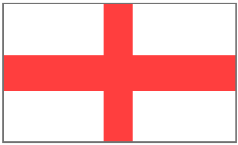  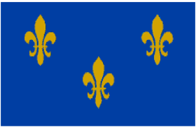  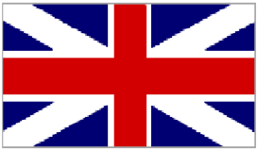    Present Day Royal Union Flag  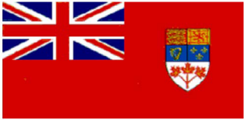  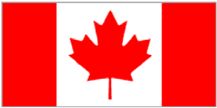  Interactive Lecture  Hand out copy of words to anthem, play CD of music and have cdts sing through.
Confirmation
Q1. What was the first flag flown over Canadian soil?
A1. The St. George’s Cross.

Q2. What are the two official colours of Canada that are incorporated in the current National Flag of Canada?
A2. Red and white.

Q3. On what date was the current National Flag of Canada made official?
A3. 15 February 1965.

Q4. On what date did the national anthem become official?
A1. 1 July 1980.

Q5. In what year were the English lyrics written?
A3. 1908

Stage 2 of 2 | Time | Action
Introduction
TP 3: Discuss the Canadian Coat of Arms | 7 min incl act after TP 4 | Activity/  Interactive Lecture
Body
Put complete Coat of Arms on flipchart to show finished product. As teaching each component, “build” second one beside it.  BACKGROUND  - His Majesty King George V appointed Canadian Coat of Arms to Canada in court of Buckingham Palace on 21 November 1921.  DESCRIPTION OF THE ARMS  The Shield  - represents Canada’s origins by depicting three royal lions of England, royal lion of Scotland, royal fleur-de-lis of France, and royal Irish harp of Tara.  - All of these nations played an integral roll in settlement of Canada.  - At base of shield is a sprig of three Canadian maple leaves that represent Canadians of all origins.  The Ribbon  - added to Canadian Coat of Arms on 12 July 1994.  - contains motto of the Order of Canada, which in Latin reads: “Desiderantes Meliorem Patriam.”  - translates to “They desire a better country”  The Crest  - consists of wreath made of twisted red and white silk  - On top of wreath stands a crowned gold lion holding a red maple leaf in its right paw  - lion is a symbol of valour and courage  - crest is used to mark sovereignty of Canada.  The Supporters  - depicted on either side of shield  - lion is on shield’s right holding a gold pointed silver lance from which flies Royal Union Flag  - unicorn is on shield’s left holding a lance flying banner of royalist France  - two banners represent two principle founding nations that established Canada’s laws and customs  The Motto  - Reads: A mari usque ad mare (From Sea to Sea)  - first used in 1906 during a sitting of Legislative Assembly of Saskatchewan.  - proposed to be new motto of the Coat of Arms and became official when Arms was proclaimed in 1921.  The Four Floral Emblems  floral emblems are:  - English rose  - Scottish thistle  - Irish shamrock, and  - French fleur-delis.  located at base of Arms and are associated w/ Canadian Monarchy.  The Imperial Crown  - sits at top of Canadian Coat of Arms and indicates presence of a monarch as Canada’s head of state.  Canadian Coat of Arms can be recognized as Cadet Chief Petty Officer 1st Class/ Cadet Chief Warrant Officer/ Cadet Warrant Officer 1st Class rank badge.  TP 4: Discuss the Maple Leaf  - began to serve as a Canadian symbol as early as 1700  - August 1860, leaf was adopted as national emblem of Canada for use as decorations during a visit by Prince of Wales.  - During confederation in 1867, Toronto schoolmaster Alexander Muir composed The Maple Leaf Forever as Canada’s confederation song  - Many regiments during both World War I and II adorned uniforms with maple leaf while over seas  - incorporated into The National Flag of Canada in 1965. | 3 mins  2 mins | 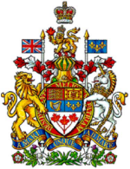  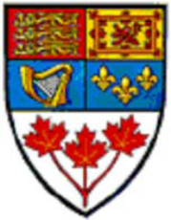  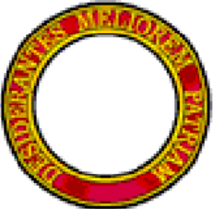  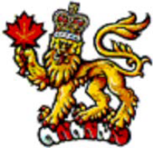  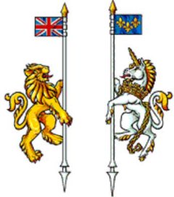  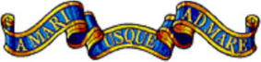  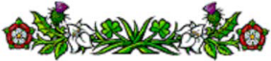  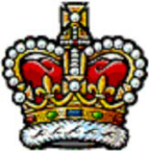  Interactive Lecture  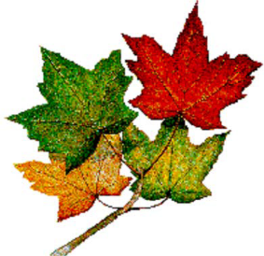
Confirmation
ACTIVITY OBJECTIVE  - Confirm material delivered in TP3 by completing puzzles of Canadian Coat of Arms.  RESOURCES  - Cut outs of different pieces of Canadian Coat of Arms found in Annex A. Envelopes for each collection of cutouts.  ACTIVITY LAYOUT  - Prepare four to five envelopes containing cut out pieces of Canadian Coat of Arms found at Annex A.  - Have a large picture or OHP transparency of Coat of Arms posted in classroom where all can easily see it.  - Divide cadets into four to five small groups.  - Hand out one envelope per group.  - Using large picture of arms as a guide, have cdts build Canadian Coat of Arms in their groups using pieces provided in envelopes.  - When groups are complete, confirm that Coat of Arms is pieced together correctly. | 4 mins

End of Lesson Confirmation / Test | Time | Action
Introduction
In this lesson we have discussed history of Canadian flag, anthem and our Coat of Arms. Do you have any questions?

Confirmation Question / Activity / Test Details
Q1. What are the two official colours of Canada?
A1. Red and white.

Q2. What is the English meaning of “A mari usque ad mare?” A2. “From Sea to Sea.”

Q3. What flag was used prior to the adoption of the current national flag?
A3. The Canadian Red Ensign.

Q4. What language was our national anthem first written in?
A4. French.

Q5. What does the imperial crown represent in the Canadian Coat of Arms?
A5. The presence of a monarch as Canada’s head of state.

Conclusion | Time | Action
Summary
- National Flag of Canada;
- Canadian National Anthem
- Canadian Coat of Arms
- The maple leaf

Restatement Of Why (From Introduction)
Identifying Canadian symbols is an important aspect of being a Canadian citizen and a member of the Canadian Cadet Movement.

You should be able to easily recognize Canadian symbols in the community and at the corps/squadron.

Re-motivation
Great job with this lesson and putting together the Coat of Arms and in the singing of “O Canada”. For those who are uncertain of the words, ensure you keep reviewing them as everyone should be able to sing it without the sheet.

Safety precautions
N/A

Distribution of Handouts
N/A as handout during the lesson

Overview of next lesson
The next lesson in this PO is…………………..

